Food Topic Group Workshop

Trnava University, Trnava, Slovakia

8th/9th/10th September 2015
(Participants arrive 7th September; workshop runs from 9.00 am on 8th through to lunchtime on 10th September.)

The workshop is run as a part of SUSTAIN PROJECT. SUSTAIN is a network of 11 CPD providers in 10 EU countries, with extensive experience in Inquiry-Based Science Education (IBSE).

Through collaborative work the project aims to develop an innovative approach to linking IBSE with Education for Sustainable Development (ESD). Three major topics will be explored during this project: Energy, Food and Everyday Objects. Three European Workshops for teachers and teacher educators, based on these topics, are being held in Autumn 2015.

Details about SUSTAIN, and the parallel workshops, can be found at http://www.sustain-europe.eu/

Target group: teachers, teacher educators, pre-service teachers

Working sessions will be at Trnava University, walking distance from accommodation places.

Estimated costs: your travel expenses and if choosing hotel (not dormitory) the cost of accommodation. University dormitory is free from charges for workshop participants. Trnava University covers also expenses for 3 lunches and one dinner on Wednesday night (9. September 2015).

Preliminary outline program:

Day 1 Morning plenary session
- General introduction to ESD
- Introduction of the proposed framework when working with the topic
- Introduction of topic groups Energy and Everyday objects
- Invited speaker

Afternoon session
- Two parallel workshops on topic bread and honey in ESD

Day 2 Morning session
- Parallel workshops on topic honey and bread (groups switch)

Afternoon session
- Parallel workshops on topic vegetables and milk in ESD

Day 3 Morning session
- Parallel workshops on topic vegetables and milk in ESD (groups switch)
- Assessment , closing.

 | Morning session  (9.00 a.m. - 12.00 a.m.) |  | Afternoon session  (2.00 p.m. – 5.00 p.m.)
8.9.2015 Tuesday | Plenary session  - ESD intro  - General framework FOOD  - Intro of Energy and Everyday objects  - Invited speaker  - Organisational remarks |  | Group 1 | Group 2
9.9.2015 Wednesday | Group 1 | Group 2 | Group 1 | Group 2
10.9.2015 Thursday | Group 1 | Group 2 | Plenary session Closing, Evaluation

Pädagogische Hochschule Wien, Austria / bread
Freie Universität Berlin, Germany / honey
Vinca Institute, Serbia / vegetable (?)
Trnava University, Slovakia / milk

The objective of the workshop is to share ways how to present ideas of sustainability to our students so they become responsible about their everyday decisions and consequently about their lifestyle. The general framework for the topic FOOD in ESD leads students through ideas about composition (nutrition), producing (growing), distributing and consuming particular food (commodity) all interconnected with environment, society and economy empowering them with knowledge and skills, discussing their attitudes and values.

Workshops and plenary sessions offer:
- strategies how to draw some general ideas how to work with any commodity (material suitable for CPD providers or teachers),
- ideas what kind of knowledge, skills and attitudes are required to shape a sustainable future for the topic FOOD,
- examples of activities connecting
- 3 pillars of sustainable development (environment, society, economy),
- inquiry based approach to explore those pillars:
- basic and integrated science process skills: observing, inferring, measuring, communicating, classifying, predicting, hypothesizing, working with variables, etc.,
- working with data: collecting data, analyzing them, identifying reliable sources, learning about basic statistical handling of data, interpretation of data, etc.,
- drawing conclusions, identifying discrepancies, argumentation, etc.

Workshop in Trnava, Slovakia also offers:
- sightseeing of historical parts of the city,
- dinner (Slovak specialty) with wine tasting (Trnava region being a vineyard area).

Accommodation possible:
- at University Dormitory (free from charges)
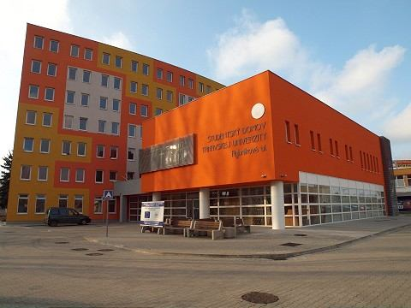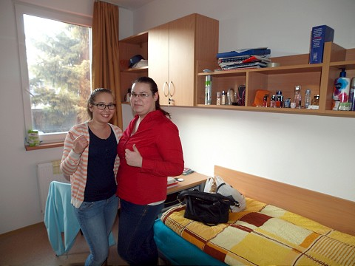

- hotels and guest houses in Trnava.

Hotels and guest houses in the center of Trnava:
- Holiday Inn http://www.holidayinn-trnava.sk/en/
- Patriot Guest House www.penzionpatriot.sk/en
- Hotel Dream http://www.hoteldream.sk/en/hotel/
- Holiday Guest House http://www.penzionholiday.sk/en/index.htm

REGISTRATION DEADLINE: 30. June 2015

REGISTRATION FORM

